Steps for logging in on Plume / SVR/ Eero/ Camera:

1. Go to <http://localhost:8081/login>
   * On the browser, there will be a bookmark assigned labeled Plume Login, SVR Login or Eero Login

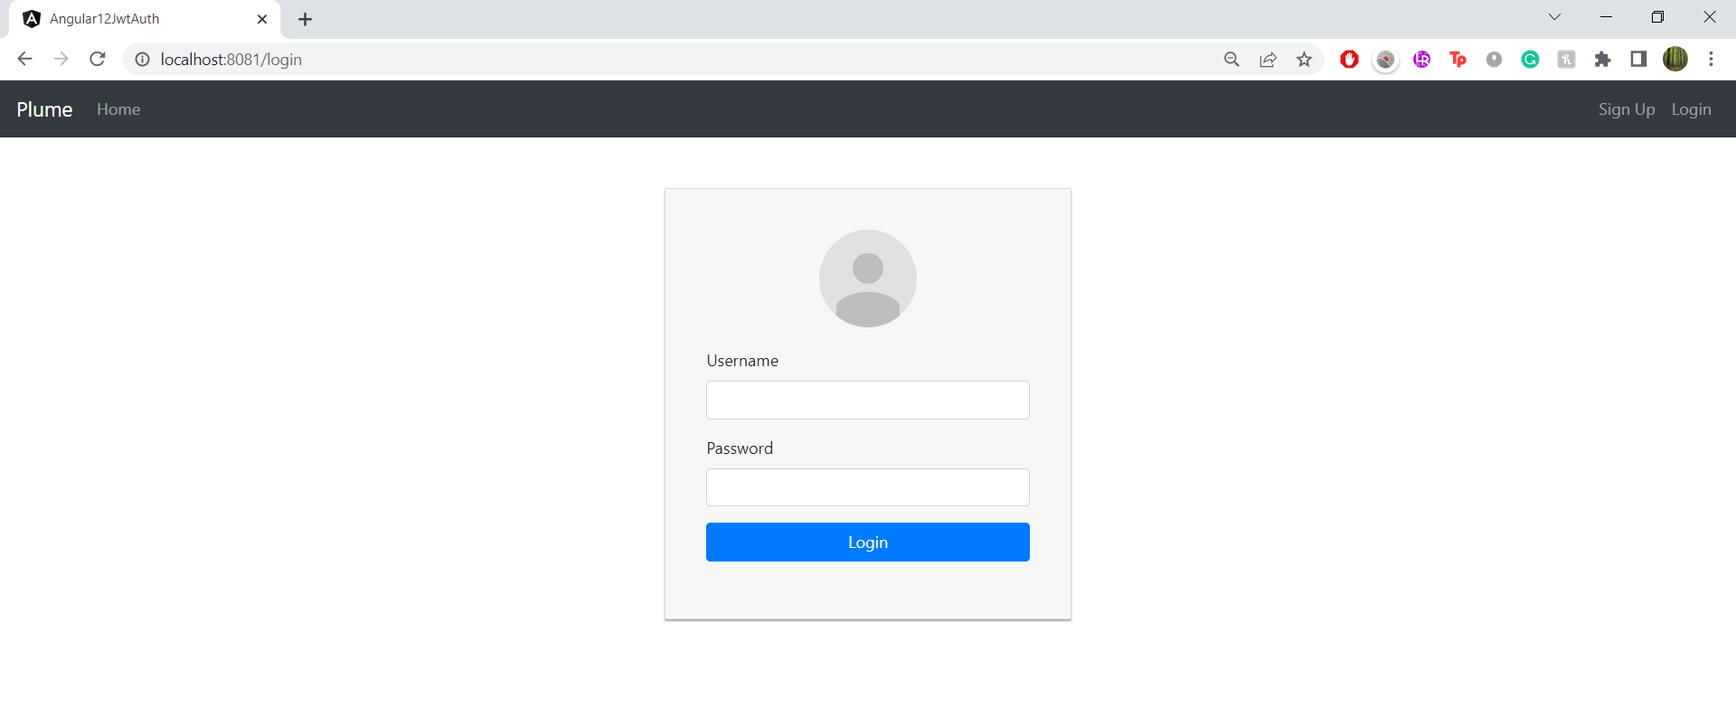

1. Enter in an operator ID in the username field and *password* in the password field (all operators have the same password)

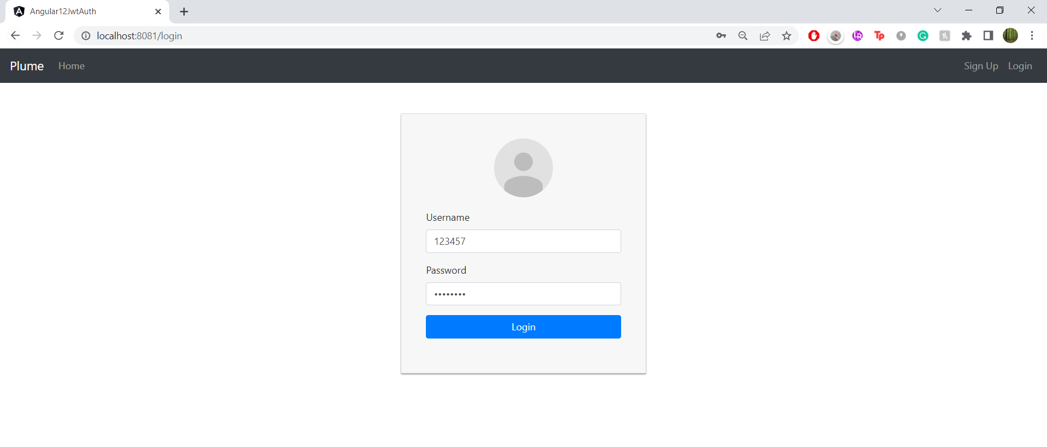

1. After a successful login you will see this screen

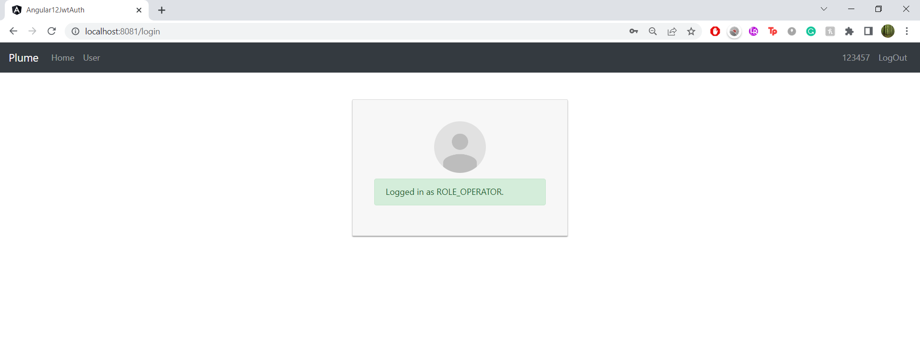

1. Operator can now begin testing normally
2. To log out, click on the LogOut button on the top right corner

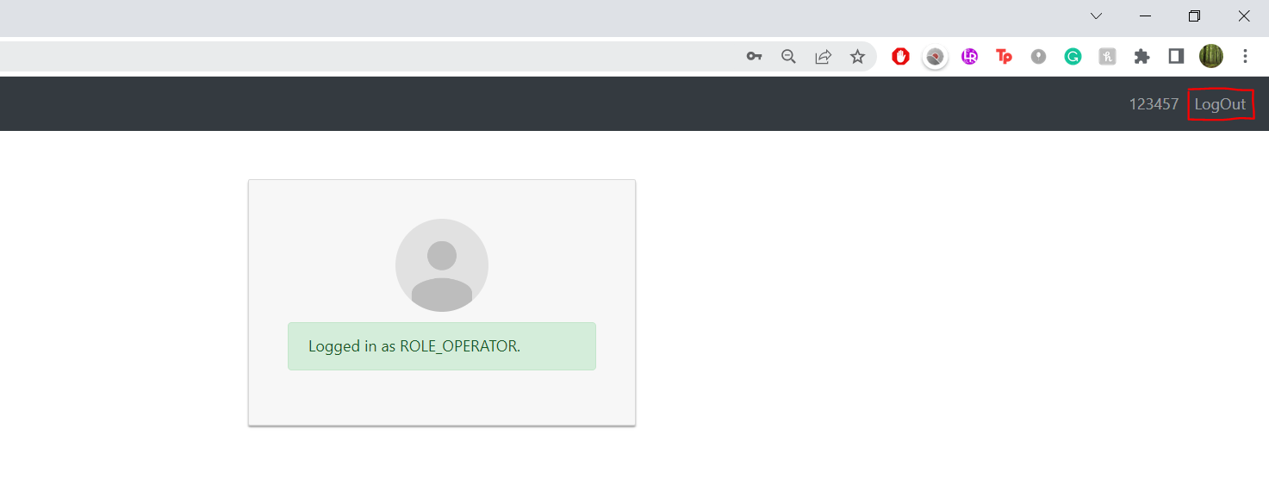

1. You will now see this screen:

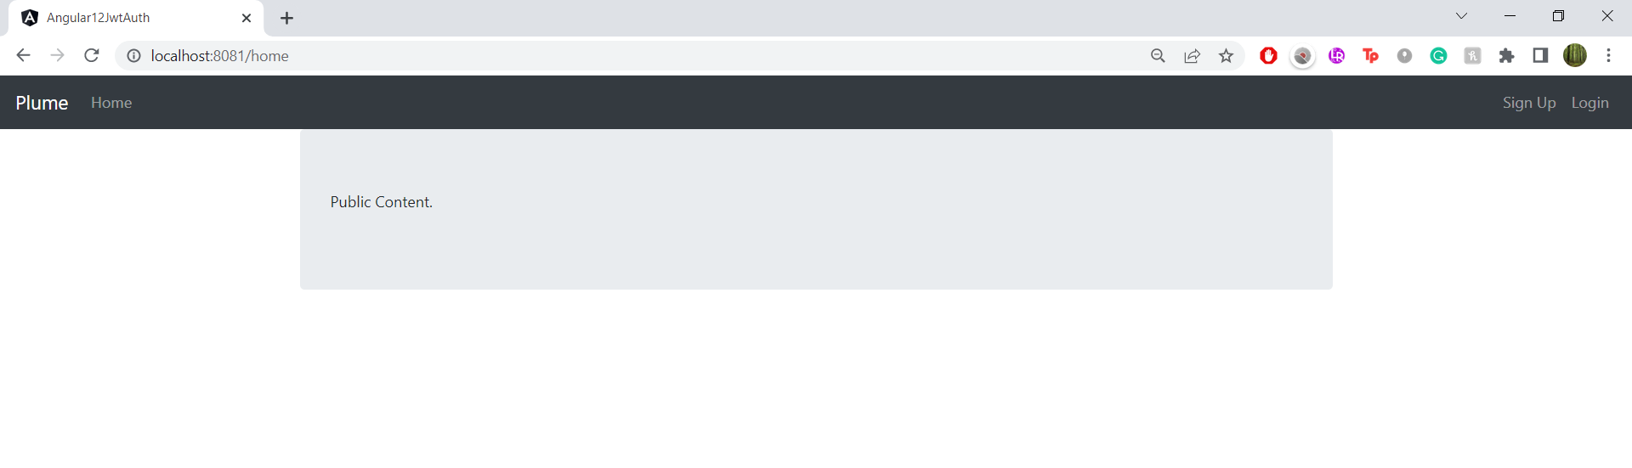

1. Click on Login, to log in another operator.